**Jurnal El-Pustaka: 03 (01): 01-13 (2022)**

DOI: 10.24042/el-pustaka.v3i1.12302

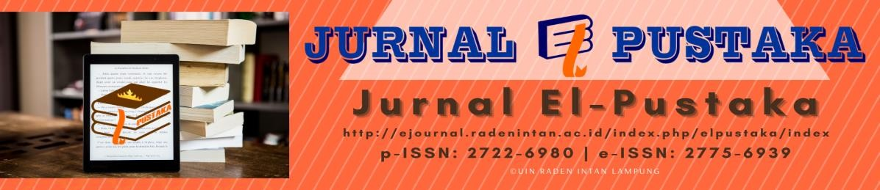

UTILIZATION OF POP-UP BOOK AS A LEARNING MEDIA FOR STUDENT OF MAJOR OF LIBRARY SCIENCE

**Nizamiyati1, Fegi Sentiana2, Faizafati Matus Zahro3; Faridah Hilmiarhani4, Aldy Gyan Dinasta5, Nopi Fajriani6**

16Institut Teknologi dan Bisnis Diniyyah Lampung, Indonesia 234Universitas Islam Negeri Raden Intan Lampung, Indonesia 5Pojok Baca Bilqis Hafizah Lampung Barat, Indonesia

|  |  |
| --- | --- |
| **Article History:** Received: Jan 31st, 2022 Revised: Mar 1st, 2022 Accepted: Apr 22nd, 2022 Published: June 30th, 2022  **Keywords:**  Library, Library Science, Pop-Up Media  **\*Correspondence Address:**  [aldigiyandinasta@gmail.com](mailto:aldigiyandinasta@gmail.com) | **Abstract:** A library is a room, part of a building where books are stored for reading. Some people's understanding of libraries is also developing. There is no doubt that the library is a very important/vital tool for all levels of society, both for developed countries, developing countries and even poor countries. Therefore, it takes a graduate majoring in library science to process libraries. The Department of Library Science is a department that learns how to collect, analyze , process, manage, and communicate information from various media, such as documents, books, or digital. So the department of library science is required to prepare media to make it easier for prospective librarians to easily understand the processing of library materials in the library. One of the media that can help facilitate According to Dzuanda (2011: 11) Pop-Up Book is a book that has moving parts or has three-dimensional elements and provides a more interesting visualization of stories, starting from the image display. which can be moved ak when the page is opened. The purpose was made to help facilitate students in the learning process through the media pop-up book. |

# INTRODUCTION

Pop-up books are considered suitable as a medium for learning how to process library materials due to the ability of pop-up books to generate interest for their readers. With various displays that can move on each page of the pop-up book, it can motivate users to read as well as stimulate their interest in the subjects in the book, namely material about processing library materials. In user education activities carried out in research, pop-up books work like guidebooks commonly used in educational activities for library users in general. However, because of its special features, pop-up books have

become a new medium that is believed to be more interesting and innovative than the usual print media.

Bluemel and Rhonda stated that, workers in education and libraries today, namely teachers and librarians face the same obstacles. Every day they have to convey messages in text form to young people, as well as must gather enthusiastic responses from them, while the texts used are found in media that looks boring, like paper in general. However, there is one print format that has a strong appeal to readers of all ages, from toddlers to adults. This print format is especially effective when used to promote love stories, motivate reading and stimulate interest in the subject at hand. That thing is a pop-up book (2012: 2). Dyk also stated that since the early 800's, pop-up books have been encouraging and attracting readers and non-readers from young to old (2011: 4). The existence of page variations in pop-up books that have three-dimensional images can increase concentration and provide diverse experiences for readers (Ma et al., 2014: 90).

a study was conducted on the steps of processing library materials for students of the Islamic library and information science study program at UIN Raden Intan Lampung using a new media that had never been used before, namely a pop-up book. The selection of this age level is based on the consideration that students' ability to reason and think logically in solving a particular problem has developed. Users like learning activities using pop-up books because they package material to be interesting and easy to understand.1

# THEORETICAL SUPPORT (OPTIONAL)

Libraries are windows to the world, people can know and understand the developments of the times through reading. With a love of reading will increase one's knowledge, those who previously did not know will become aware. Books are an opener for our eyes, from only a book we can find out the contents of the world as well as invaluable knowledge. In the use of learning media and required the right selection so that it can function effectively and have an appeal. In a learning process in the department of library science the use of media is very important. This is because if in the learning process there is material in the teaching material that is not clear, it will be conveyed using assistive devices. Difficult learning materials can be simplified through

1 Mezan el-Khaeri Kesuma et al., “Penerapan Slims Pada Layanan Sirkulasi Di Perpustakaan Instidla,” *Al Maktabah* 6, no. 2 (2021): 103–14.

learning media made using words that are easier to understand for users/visitors. Media is divided into two, namely, two-dimensional and three-dimensional media.

According to Siti Umayah, three-dimensional learning media are learning media in the form of real objects or in the form of three-dimensional images. The actual object or three-dimensional image can help students understand, imagine and analyze the shape of the image that must be drawn. three-dimensional learning media design must be optimal, requires teamwork and infrastructure support, either in the form of media or other source.2

One of the three-dimensional media is Pop-Up Book. Pop-Up Book media is a book-shaped media that has three-dimensional elements and motion. In Pop-Up Books, the material is presented in the form of attractive pictures because there are parts which if opened can move, change or give the impression of arising. According to Dzuanda, Pop- Up Book is a book that has moving parts or has three-dimensional elements and provide a more interesting visualization of the story, starting from the display of images that can move when the page is opened. According to Bluemel and Taylor, Pop-Up Book media has the ability to strengthen the impression to be conveyed in a material so as to make the material easier to remember and learn. In addition, this media can also attract attention and increase learning motivation. Therefore, we choose pop-up books as learning media which we consider very effective in helping one's understanding of the library. For us, we describe the steps for processing library materials, namely: inventory, cataloging, calling numbers (call numbers), and book bags. After their model is trained, they developed a lightweight wrapper library to integrate their trained model to CFD code for inference while calculating.3

# Inventory

Inventory of library materials is the activity of recording the addition of library materials into the main book properly and regularly so that it can be seen the variety of library materials owned by the library and their number. it is easy to make statistics and reports on several things, namely: (1) the number of library materials owned by the

2 Mezan el-Khaeri Kesuma and Reni Puspita Sari, “Pengembangan Modul Sharaf Dengan Pendekatan Deduktif Di Pondok Modern Madinah Lampung,” *Studi Arab* 11, no. 1 (2020): 27–36, https://doi.org/10.35891/sa.v11i1.1944.

3 Lei Zhou et al., “Machine Learning for Combustion,” *Energy and AI* 7 (2022): 100128, https://doi.org/10.1016/j.egyai.2021.100128.

library, (2) the number of titles and copies, (3) the number of titles and copies by language, (4) the number of fiction books, textbooks, books references, etc., (5) the number of additions to library materials each year, and (6) the amount of budget issued. Purpose of Inventory So that libraries can:

1. Control ownership of library materials
2. Create statistics;
3. Knowing the library materials that are owned or not owned
4. Knowing the variety of library materials owned
5. Knowing the amount of library materials owned at a certain time and the number of missing library materials
6. Making existing data as report material
7. Making existing data as material for compiling evaluation of collections/library materials Example of inventory:

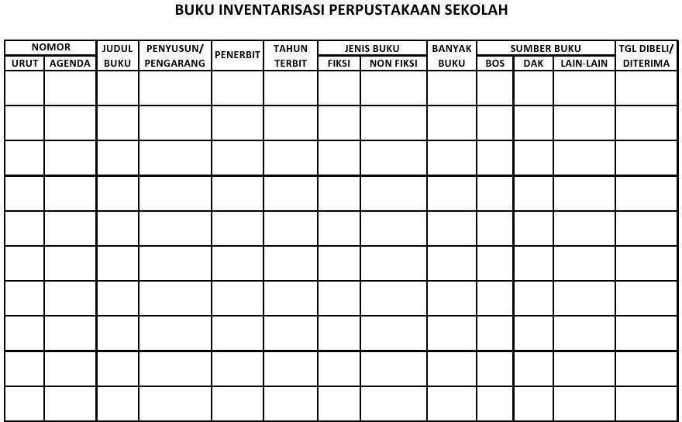

# Cataloging

Catalog is a general term that is often interpreted as a list of goods or objects contained in a certain place. As a general term, this catalog is often found in publishers, exhibition venues, bookstores, libraries, or even supermarkets. These catalogs usually contain information that needs to be known by the general public, for example a

publisher's catalog is information on a list of library materials that have been or will be published by one or more publishers containing information about the author, title of library material, edition, year. In relation to the library, catalog means a list of library materials in the form of books or non-books such as magazines, newspapers, microfilms, slides and others that are owned and stored in a library or group.4 The library catalog contains important information from a library material that is usually used by library visitors as information material, which involves the physical library material, content, or other information, such as the title of the library material, the name of the author, edition, print, city of publication, publisher, year of publication, subject of discussion, ISBN, and others. The function and purpose of the catalog:

1. To provide facilities for someone to find library materials that are known to the author's rank, title or subject quickly, precisely, and accurately.
2. Shows library materials owned by libraries by certain authors based on certain subjects or related subjects and certain types or forms of literature.
3. Assist in the selection of library materials based on edition and character (literary or topic-based)

The catalog consists of 4 types, namely card catalogs, files, books, and OPAC *(online Public Access Documents)*

Examples of card catalogs:

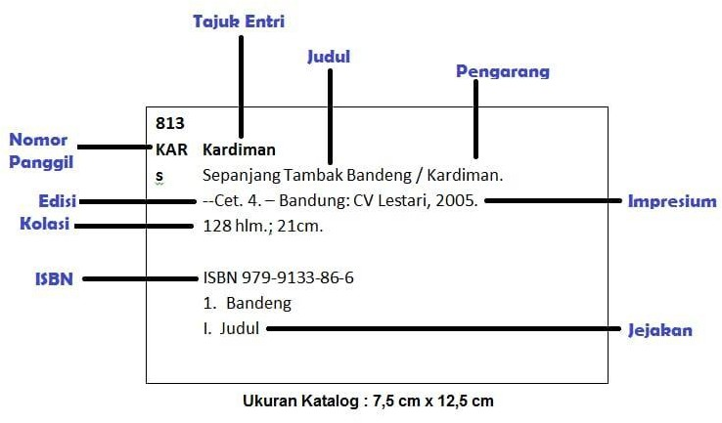

4 Era Octafiona and Ahmad Bashori, “Kesiapan Arsiparis Menggunakan E -Arsip Dalam Tata Kelola Kearsipan Fakultas Tarbiyah Dan Keguruan Uin Raden Intan Lampung,” *El-Pustaka: Jurnal Ilmu Kepustakaan Dan Informasi Islam* 01, no. 01 (2020): 86–99.

# Call Number

Number Call number or Call Number is a code consisting of from the classification number, three letters of the name of the individual author after being reversed or the name of the institution as the author, and the first letter of the title of the library material. This code is written

on book spines, book cards, book bags, and catalogs. A call number or Call Number is a code created for a library material so that the library material can be easily identified, arranged in a catalog or on a shelf, and easy to trace. So from the above understanding it can be concluded that a calling number or Call Number is a code consisting of a classification number, three initial letters of the author or body, and one initial letter of the title or person in charge. This code is written on the back of the book with a distance of 3 cm from the bottom of the book. The part of the call number or call number can be divided into three parts, namely:

1. Subject classification

number The classification number used in the call number is the classification number which states the main content of the material/subject of the book in question, which is written at the very bottom of the book.

1. The main entry

header The main entry header commonly used is the name of the author or cooperative body responsible for the contents of a library material. Where the first three letters of the name of the author or the responsible cooperative body are written in capital letters (capital letters) are written under the classification number. more than three people, then the title of the book in question is determined as the title of the main entry. And still written the first three letters of the title in capital letters (capital letters). Thus, the title does not need to be written again.

1. Title The

title of a book or paper, etc., is usually written the first letter of the title of the library material, which is written in lowercase. Written on the last line after the main entry header.

Giving the same calling number is very beneficial to library users, namely:

* 1. Users are shown the classification subject grouping used by the library.
  2. Users can browse the library materials they are looking for in the catalog that has been provided, by recording the calling number and then searching for books with the same call on the library material shelf.
  3. If the user cannot find the same book, then he can find library materials that have almost the same subject/subject.
  4. Make it easy for users to match calling numbers recorded from catalog cards just by looking at the calling numbers affixed to the label

Example of call number/calling number :

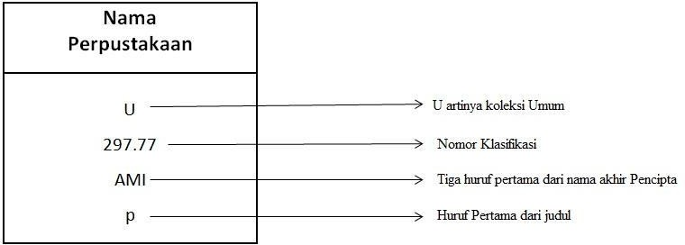

# Book bag

for Library Material Processing Division of the National Library of Indonesia in processing library materials for collection services in Salemba and Merdeka Selatan no longer use cards and book bags as well as borrowing cards, because for services in Salemba using a closed system, while for collections at Merdeka Selatan, RFID is used. However, the library collections at the UPT at the Bung Karno Proclamation Library in Blitar City, East Java and the Bung Hatta Proclaimer Library in Bukit Tinggi City (West Sumatra) still require borrowing using a book card and book bag. Each book must be accompanied by a date slip. ) and book cards and their book pockets which are affixed to the last column and the inner cover of the book. The date slip serves to affix the return date of the borrowed book. The book pocket is used to place book cards, both of which must be affixed with information about the calling number, author's name and title of the book. While the book card (book card) to be able to find out who borrowed and what date must be returned. The card must be filed at the time the book is being loaned.

Examples of Book Cards and Book Bags:

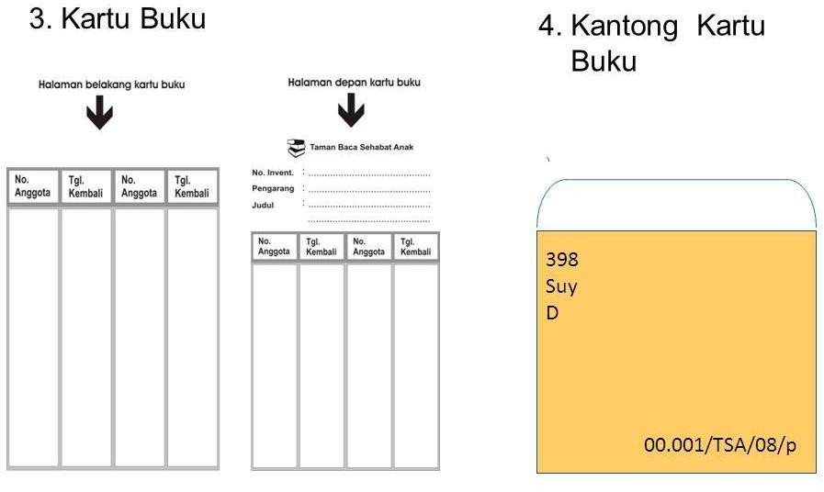

# METHOD

This study uses a behavioral measure method for students majoring in Islamic library and information science and qualitatively by analyzing published journals and books. Expert knowledge used as a source such as library books and internist doctor.5

The research method used by researchers in this study is a qualitative approach with a descriptive method. The research method used is a qualitative method. "Methodology is the process, principles, and procedures that we use to approach problems and seek answers" (Mulyana, 2008: 145). According to Sugiyono (2007: 1), qualitative research methods are research used to examine natural objects where the researcher is the key instrument, data collection techniques are carried out in a combined manner, data analysis is inductive, and qualitative research results emphasize meaning rather than generalization.6

Qualitative research aims to maintain the form and content of human behavior and analyze its qualities, instead of turning them into quantitative entities (Mulyana, 2008: 150). The purpose of this descriptive research is to make a systematic, factual and accurate description, picture or painting of the facts, characteristics and relationships between the investigated phenomena.

# RESULT AND DISCUSSION

* + 1. Libraries

5 I Ketut Gede Darma Putra and Putu Manik Prihatini, “Fuzzy Expert System for Tropical Infectious Disease by Certainty Factor,” *TELKOMNIKA (Telecommunication Computing Electronics and Control)* 10, no. 4 (2012): 825, https://doi.org/10.12928/telkomnika.v10i4.872.

6 Kesuma et al., “Penerapan Slims Pada Layanan Sirkulasi Di Perpustakaan Instidla.”

Explain the meaning of libraries and provide an overview of libraries

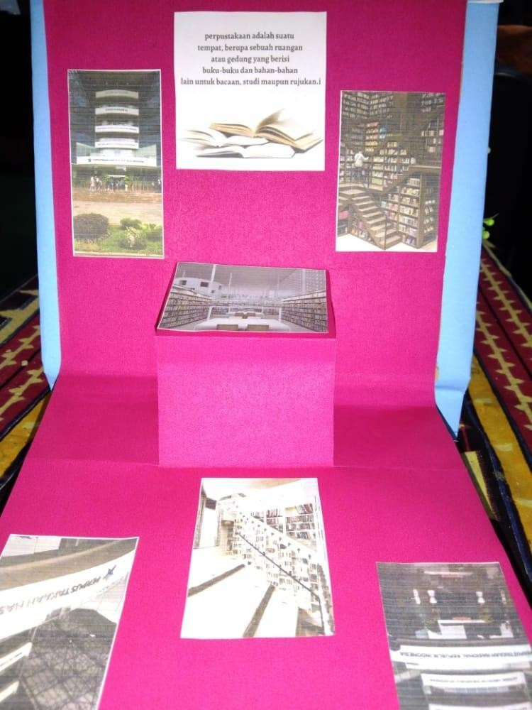

2 Media libraries and books

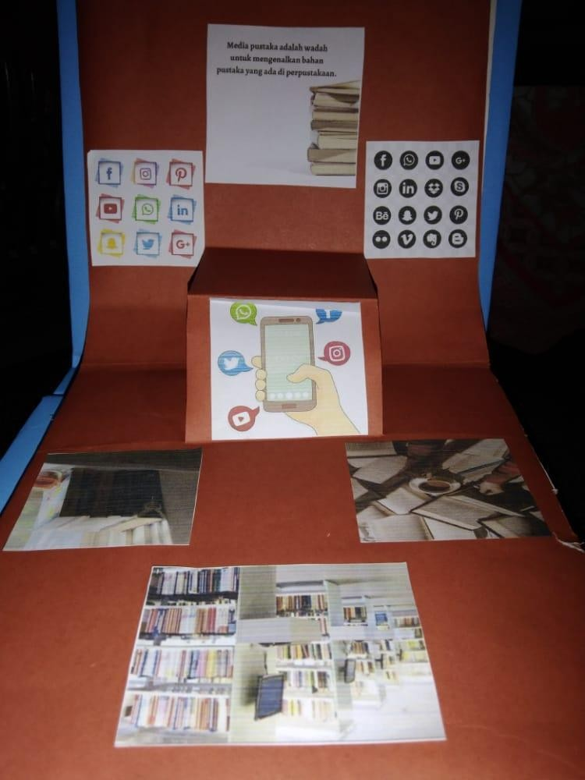

Technology or any media that can be used to promote library materials and provide an overview of books.

1. Inventory and catalogs

Provide an overview of how to make inventory and

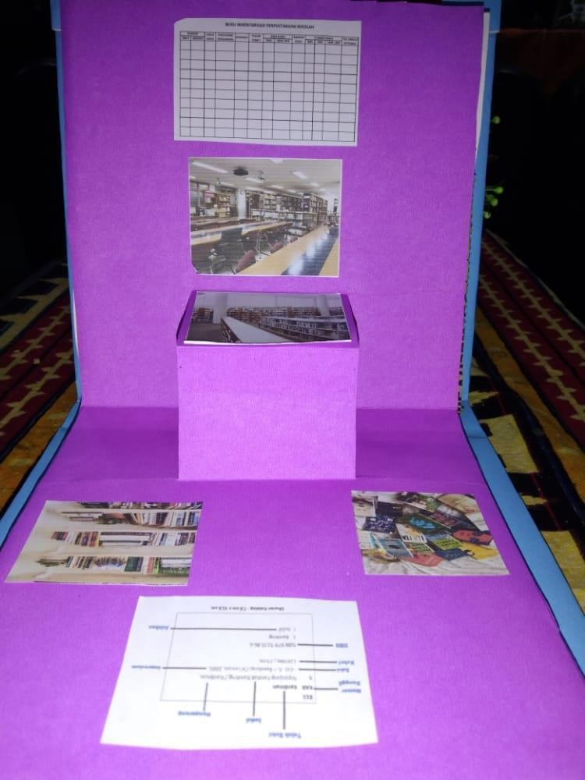

1. Call numbers and book bags

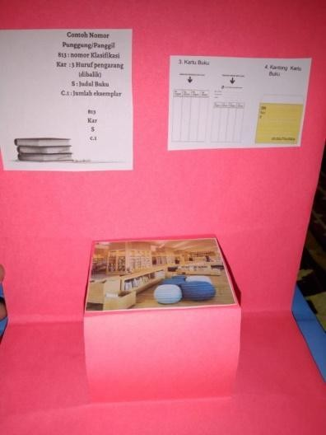Provide examples of making call numbers and book bags

After Using this media, students who previously did not understand the processing of library materials could easily understand. With this Pop Up book, it can create interest in students in learning, so that the results of the learning process will increase. Therefore, learning to process library materials is also expected to increase with the use of this pop up book media. There is an interest in students in learning, so that the results of the learning process will increase. Therefore, learning to process library materials is also expected to increase with the use of this pop up book media.

# CONCLUSION

Libraries are windows to the world, people can know and understand the developments of the times through reading. With a love of reading will increase one's knowledge, those who previously did not know will become aware. Books are an opener to our view, from only a book we can find out the contents of the world and knowledge that is priceless. It takes prospective librarians who are experts in information, one of which is a graduate student majoring in library science. To get graduates who are experts and competent. So we need learning media that can facilitate the learning process in library science. Pop-up books are very effective and interesting media in the learning process for students majoring in library science.). Bluemel and Rhonda stated that pop-up books are books that offer the potential to trough motion and interaction using paper mechanisms such as folds, rolls, slides, tabs, or wheels. These books don't always "pop" but they have motion. In processing library materials, there are steps such as: inventory, cataloging, call numbers and book bags. Inventory aims to find out what collections are in the library. Catalog as a representative document. Call number aims to make it easier for users to match calling numbers recorded from catalog cards just by looking at the call numbers affixed to the label. The book bag serves to affix the return date of borrowed books.

# REFERENCES

Handaruni Dewanti, et al.2018. Media Development Pop-Up Book For Learning Environment Of My Living Place Class IV SDN 1 Pakunden, Ponorogo

Kesuma, Mezan el-Khaeri, and Reni Puspita Sari. “Pengembangan Modul Sharaf Dengan Pendekatan Deduktif Di Pondok Modern Madinah Lampung.” *Studi Arab* 11, no. 1

(2020): 27–36. https://doi.org/10.35891/sa.v11i1.1944.

Kesuma, Mezan el-Khaeri, Irva Yunita, Jaka Fitra, Nadya Amalia Sholiha, and Herlini Oktaria. “Penerapan Slims Pada Layanan Sirkulasi Di Perpustakaan Instidla.” *Al Maktabah* 6, no. 2 (2021): 103–14.

Mutia nanda & suherman. 2018. Analysis of Students' Ability in Determining Notation Based on the DDC (Dewey Decimal Classification) Classification System as a Source for Making Call Numbers (Case Study on Students of S1 Library Science Study Program Class of 2014. Banda Aceh : UIN Ar-Raniry

Octafiona, Era, and Ahmad Bashori. “Kesiapan Arsiparis Menggunakan E -Arsip Dalam Tata Kelola Kearsipan Fakultas Tarbiyah Dan Keguruan Uin Raden Intan Lampung.” *El-Pustaka: Jurnal Ilmu Kepustakaan Dan Informasi Islam* 01, no. 01 (2020): 86–99.

Putra, I Ketut Gede Darma, and Putu Manik Prihatini. “Fuzzy Expert System for Tropical Infectious Disease by Certainty Factor.” *TELKOMNIKA (Telecommunication Computing Electronics and Control)* 10, no. 4 (2012): 825. https://doi.org/10.12928/telkomnika.v10i4.872.

Perpustakaan Institut Perkebunan Bogor. Definition, Duties and Functions of Libraries.

Bogor : IPB university

Perpustakaan Institutu Seni Yogyakarta <http://digilib.isi.ac.id/3027/1/Panduan%20AF%20update.pdf>

Suhendar yaya. 2016. Cataloging Guidelines. Jakarta : Kencana

Zhou, Lei, Yuntong Song, Weiqi Ji, and Haiqiao Wei. “Machine Learning for Combustion.” *Energy and AI* 7 (2022): 100128.

https://doi.org/10.1016/j.egyai.2021.100128.